Nature Trails
by Sian McGhee (Childhood Practitioner)

Wildreness Walks & Activities
Glendaruel: Chambered Cairns / Modan’s Well

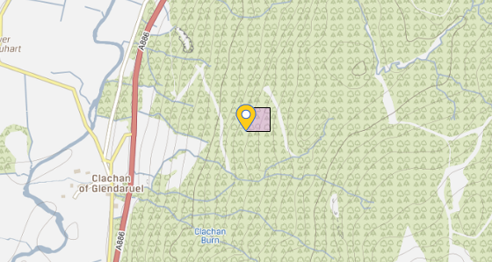
This map shows the location of the chambered cairns & modan’s well. The walk starts at the main road at the clachan of Glendaruel. There is signage and a layby for parking. The walk to the chambered cairns takes between 20-40 minutes one way (add 10 minutes to get to modan’s well).
This booklet contains activities related to the history of Glendaruel, the chambered cairns, moden’s well, scottish nature & wildlife as well as extended activities for you to enjoy with your bairns during this strange time.

“The best classroom and the widest cupboard is roofed only by the sky.” - Margaret McMillan (practitioner and theorist)

The Chaimbered Cairns
- The site name is Lephinkill.
- It could have been built some time around 3200 BC
- Cairns are usually built during the neolithic era.
- “Neo” meaning new, “lithic” meaning stone.
- The neolithis era was around 12,000 years ago!
- A chambered cairn is a burial monument made up of stone built chambers within a mound of stones.
- Chambered cairns are found throughout Britain and Irland, with largest number found in Scotland.
- The neolithic age is where humans began farming animals and growing crops.
- During the neolithic era, humans had to make tools out of stone.
- People grew flax and cotton for clothing instead of using animal skin.
- People domesticated animals: they tamed wolfs.
- The last wolf of Scotland died in Perthshire in 1680 (but story has it that there were some seen up to as late as 1888)
- Humans in the neolithic era also used the wool from animals, their milk and their meat.
QUESTION:
How many steps make up a meter for you? If the walk is 600 meters, how many steps will it take you?

Activity 1: Farms: what sort of farms are in your area?
Draw your own farm.

(use this space)
Neolithic humans used tools for many different jobs. They had mallets, stone axes, flint arrow heads, flint knifes and even stone for flour milling.
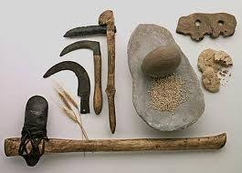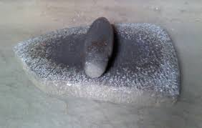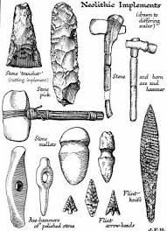

Could you design your own farm tools?
What would you have on your farm? Why?
What do you think a days work was like as a neolithic farmer 12,000 years ago?

Building shelters
During the neolithic era humans had to build shelters by hand. There were no machines to use 12,000 years ago. Maybe you have heard of a neolithic structure? Stonehenge*. A great example of neolithic architecture. Houses were built with stone and mud. A house would have been built around a hearth that was used to warm the house and to cook (do you have a fireplace in your house just like the neolithic humans?).

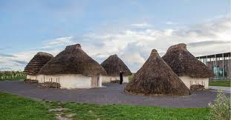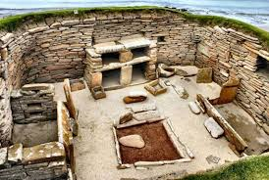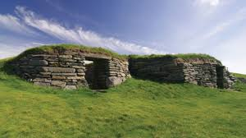

Could you design a neolithic house for your family? What material would you use?
Perhaps on your walk to the chambered cairns your could build a little shelter using material found in the forrest?

*(this could be extended by using resources to reasearch landmarks in Scotland, England, Ireland and Wales).
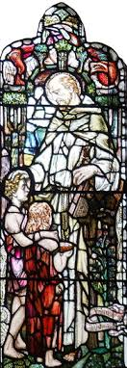
Modan’s Well
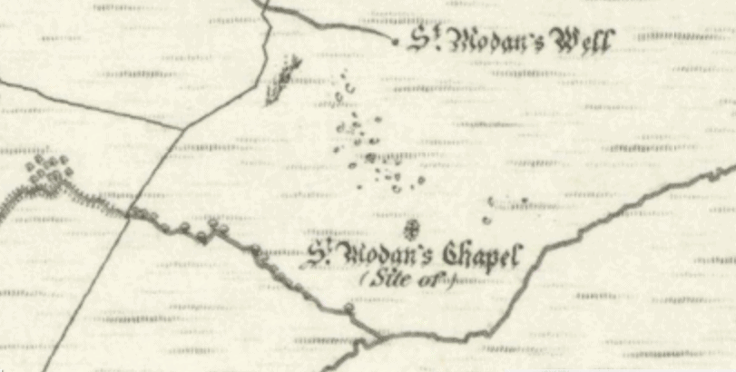
OS 6” 1sr edition map [National Library of Scotland]
- The parish church of Glendaruel is called Kilmodan, gaelic for ‘the church of Saint Modan’.
- The church is dedicated to St. Modan.
- St. Modan was an early Celtic saint who lived around the same time as St. Columba.
- The church was built in 1783 on the same site of an earlier church built around 1610 (there are no remains of the older church).
- St. Modan’s well is hard to find unless you have the right map. It is easy to miss as it is a hole in the ground!
- It is said to be the clearest source of water in Glendaruel. The walk takes you to a replica Well.
Activity 2: On the next page is space for you to research a saint and write about them.
Activity 2: All About Saint…

Patron saint of…

Feast Day…

3 Interesting Facts:

Draw them in the space above.
Activity 3: Stain Glass Art
Here’s what you need to begin:
- Black paper frames (or paper)
- Black strips of paper
- Clear contact paper sheets
- LOTS of 1″ squares of tissue paper in red, orange, yellow, green, blue, purple…
Step 1: On the contact paper, create a pattern using strips of black paper within the black frame.
Step 2: Fill in each section of your design with different colours of paper
Step 3: You will need to put a back on your art to hold it all together.
Step 4: Alternatively, you could use laminating pouches, plastic wrap or polly pockets (any clear sheeting to enclose the art so you can still see it!
Links:
https://kindercraze.com/stained-glass-kite-decorations-made/
https://kindercraze.com/rainbow-fever/

Plant ID
During your walk through the woods, up hills, past burns and in fields you might come across some of Scotland’s wildlife. Scotland is famous for its scenic views and nature. A little game of bingo will help get you acquainted with your surroundings, keep an eye out though, some of these can be hard to spot at first. The corresponding information cards create an opportunity for parents to extend the learning for bairns of all ages.
*Below you will find 3 games: one bingo sheet for tree’s and two for plants. You can print this out and take it with you or (if you have access to a device) upload it to your device and take it with you. Ideal for multiple trips. Can be used in your local area.
*Within this book there are extended activities including an activity with moss you can do at your home (page 22), the story of how the unicorn became Scotland’s national animal (page 21) and a story of how the thistle became Scotland’s national flower (that you can read at any point during your walk or at home) (page 24).
*Information in this section was gathered by visiting the site with a horticulturalist and carrying out plant identification. Further information was found in ‘Collins: Complete guide to British Trees’- Paul Sterry (2007).
*Other books include: ‘Collins: Complete British wildlife photoguide’-Paul Sterry (1997) & ‘Collins Gem: Trees’-Alastair Fitter (1980)
*A link to look at for stories and tales of Scottish plants: https://treesforlife.org.uk/
*parent/carer information
Activity 4: Bingo (tree’s)
Birch  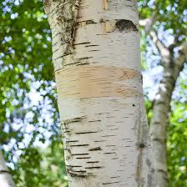 | Oak  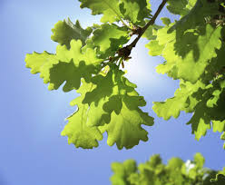 | Larch  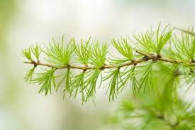
Rowan*  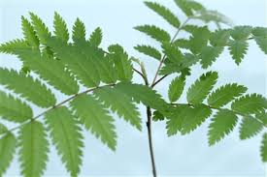 | Spruce  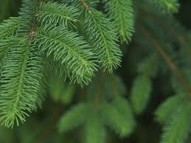 | Beech  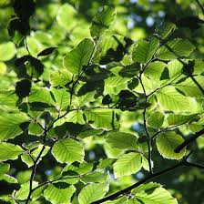
*The rowan tree was denoted as a tree of the Faerie’s by virtue of its white flowers
Information cards:
Birch (Downy Birch):  Name: Betula papyrifera  Family: Betulaceae  Height: 25m  Facts:  - Found all over Europe and UK  - Often grows alongside Silver Birch  - Smooth brown or grey bark | Oak (pedunculate):  Name: Quercus robur  Family: Fagaceae  Height: 36m  Facts:  - Deciduous tree (sheds leaves annually)  - Can be 700-800 years old  - Produces acorns | Larch (common):  Name: Larix decidua  Family: Pinaceae  Height: 35m  Facts:  - Deciduous conifer (sheds leaves annually)  - Bark can be used for tanning  - Tree can be used for straight poles
Rowan (mountain ash):  Name: Sorbus aucuparia  Family: Rosaceae  Height: 20m  Facts:  - Deciduous tree (sheds leaves)  - There are 80 different species of rowan  - They produce red berries | Spruce (Norway):  Name: Picea abies  Family: Pinaceae  Height: 44m  Facts:  - Evergreen (retains green leaves throughout the year)  - Native to Europe  - Used commonly as Christmas trees | Beech:  Name: Fagus sylvatica  Family: Fagaceae  Height: 40m  Facts:  - Deciduous tree (sheds leaves annually)  - Found all over the UK  - Produces nuts in a woody, spiny husk

Activity 5: Bingo (plants)
Wood sorrel  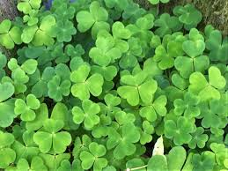 | Hawthorn*  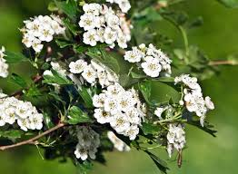 | Moss  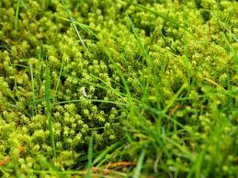
Violets (wild)  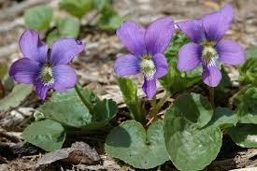 | Ferns  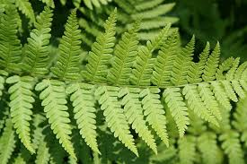 | Blue Bells  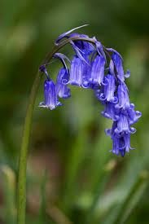
*see information card
Wood sorrel:  Facts:  - Grows a white flower  - All parts of the plant are edible and are used in soups, salads & sauces  - Has an apple like taste  - Grows around tree roots or wet boggy areas  (caution: do not eat anything without correct identification) | Hawthorn:  Facts:  - It is seen as bad luck to bring this into your home but good luck if it grows outside your house.  - The plant is said to be inhabited and protected by the Wee Folk (Faeries)  - Both Hawthorn and Rowan have white flowers and are said to be the dwelling place for Faeries  (https://treesforlife.org.uk/) | Moss:  Facts:  - Grow in damp shady areas  - Do not have a root system  - You can paint with moss and watch it grow (see activity 10)  - Can survive on solid ground (rocks, concrete)  - Apparently during the First World War moss was used as a bandage  (https://www.softschools.com/facts/plants/moss_facts/504/)
Violets:  Facts:  - They have heart shaped leaves  - Wild violets self-seed and return in unexpected locations each year  - Their Latin name: Viola odorata  - Flowers are purple/blue and sometimes white | Ferns:  Facts:  - They are a vascular plant that reproduce through spores  - They do not have seeds or flowers  - There are 10,560 known species  - Some ferns can live for 100 years | Bluebells:  Facts:  - Folklore used to tell that bluebells ring at daybreak to call faeries into the woods!  - Bluebells are protected under the Wildlife & Countryside Act 1981  - Over half the worlds population of bluebells are grown in the UK

Activity 6: Bingo: 2 (Plants)
Foxglove  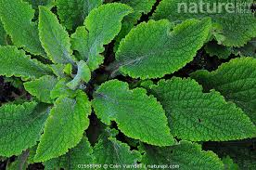 | Thistle  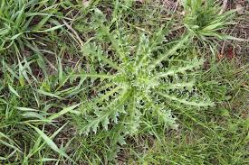 | Heather  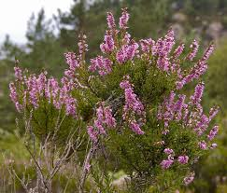
Primrose  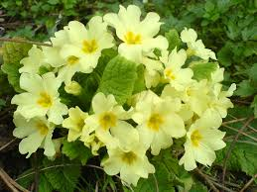 | Cotton grass  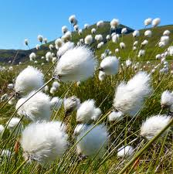 | Dandelion  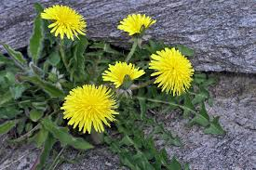

Foxglove:  Facts:  - Can reach 20-59 inches in height  - Can grow 20-80 purple-pink flowers arranged in the form of a long spike  - Flowers bloom June-September | Thistle:  Facts:  - The Thistle is Scotland’s national symbol  - One musk thistle is able to produce up to 120,000 seeds  - It is the oldest National Flower, dating back to the 13th century  (see stories) | Heather:  Facts:  - The Picts used heather to make fine ale  - The flowers are purple; but white heather exists and is said to be lucky in Scotland  - It can be used in ‘Moorland Tea’ which is said to have medicinal properties. (A favourite of Robert Burns)
Primrose:  Facts:  - Originated from the word ‘primus’ meaning ‘first’ or ‘early’ as it is one of the first flowers to bloom in spring  - Leaves and flowers are edible and have been used in salads.  (Do not eat without correct plant identification) | Cotton grass:  Facts:  - Can grow up to 12 inches in height  - Can grow in 2 inches of water  - The flower at the top of the stem appears as fluffy cotton balls – hence the name | Dandelion:  Facts:  - Represents the 3 celestial bodies of the sun: Flower-sun, Puff ball-moon & Seeds-stars  - Flowers open in the morning and close at night (like daisies)  - Every part of the dandelion is useful: roots, leaves & flower.
Activity 7: See if you can spot these beasts on your walk. Wild Beasts
Pheasant  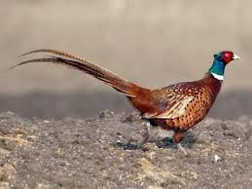 | Butterflies  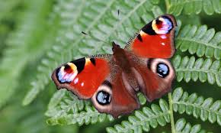 | Rabbit  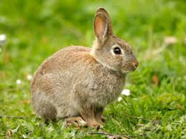
Red deer  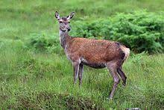 | Roe deer  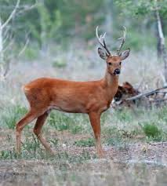 | Buzzard  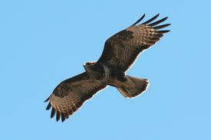
Activity 8: Draw your Scottish beast

(Use this space)
The Wee Stone of Destiny Hunt
The Stone of Destiny
The Stone of Destiny is an ancient symbol of Scotland’s monarchy, used for centuries in the inauguration of its kings. Seen as a sacred object, its earliest origins are now unknown.
In 1296, King Edward I of England seized the stone from the Scots, and had it built into a new throne at Westminster. From then on, it was used in the coronation ceremonies of the monarchs of England and then Great Britain.
On Christmas Day 1950, four Scottish students removed the stone from Westminster Abbey in London. Three months later it turned up 500 miles away – at the high altar of Arbroath Abbey.
In 1996, the stone was officially returned to Scotland. Today, it is one of the priceless treasures on display in the Crown Room, at Edinburgh castle, visited by millions of people each year. The stone will only leave Scotland again for a coronation in Westminster Abbey.
The Stone is displayed alongside the Crown Jewels in the Royal Palace on the east side of Crown Square.
(https://www.edinburghcastle.scot/see-and-do/highlights/the-stone-of-destiny)

Activity 9:
- The walk to the chambered cairns is scattered with little blue stones (Wee stones of destiny).
As you walk through the woods to the chambered cairns, how many can you find on the trail? What pictures do they have on them? And what do they say on the back?
- Can you make your own at home?
Gather up some rocks and paint and create your own Wee stone of destiny at home!

*Fun Fact: You will find a few unicorns on your travels. Why a unicorn? Did you know that Scotland’s national animal is the unicorn?
In Celtic mythology the unicorn was a symbol of purity and innocence, as well as masculinity and power. Tales of dominance and chivalry associated with the unicorn may be why it was chosen as Scotland’s national animal.

(See next page for the story)
THE UNICORN IN THE HISTORY OF SCOTLAND
With Scotland being famed for its love for and long history of myths and legends, it is no surprise that a fabled creature such as the unicorn is Scotland’s national animal. Unicorns have been linked to Scotland for centuries. While the animal is mythological, the ideals it represents are what make it a perfect fit as the national animal for Scotland, and because like this proud beast – Scots would fight to remain unconquered.
The unicorn was first used on the Scottish royal coat of arms by William I in the 12th century. In the 15th century, when King James III was in power, gold coins even appeared with the unicorn on them. When Scotland and England unified under the reign of James VI of Scotland in 1603, the Scottish Royal Arms had two unicorns supporting a shield. When James VI became James I of England and Ireland, he replaced the unicorn on the left of the shield with the national animal of England, the lion, to show that the countries were indeed united.
WHY IS THE UNICORN CHAINED?
The unicorn representing Scotland in the coat of arms is always depicted bounded by a golden chain, which is often seen passing around its neck and wrapping all around its body. The unicorn was believed to be the strongest of all animals – wild and untamed, and that it could only be humbled by a young maiden. It is possible that the entrapment symbolises the power of the Scottish kings – they were strong enough to tame even a unicorn.

(https://www.visitscotland.com/about/uniquely-scottish/national-animal-unicorn/)
Activity 10:
What is moss?
Moss is a small, rootless, non-flowering plant that can grow in all sorts of places such as bare rocks, trees, decaying wood, roofs, streams and ponds however it will not be found in salt water. It grows in clumps which gives us that illusion of a lush, green carpet but if you look closely you will see that these clumps are made up of several individual plants growing closely together. There are over 12,000 species of moss, most are perennial and will continue to grow annually at the tips of the stem and branches. Moss experiences the highest amount of growth during the winter months where there is plenty of water and low light levels.
How does moss help the environment?
Moss helps the environment in many ways. An area carpeted with moss will help prevent soil erosion, which is where the surface layer of the soil is displaced by wind and rain. Moss absorbs moisture easily and then allows the water to gradually soak into the earth instead of running of the surface. Moss can also make an area more habitable for other plants to grow in by disintegrating rocks. Moss found growing on the surface of a rock can release acidic compounds, which when combined with water cause chemical weathering and eventually disintegrate the rock, allowing the moss to take its valuable minerals. The moss adds nutrients into the soil once it has died and decayed.
(See next page for moss painting)

Moss Painting:
Collect (about 1 cup full) and put it into an old food blender (perhaps with some water). Add 2 tbsp at a time of each until you get the consistency that you want.
Have a go at painting on a wall in the garden and hopefully in as little as two weeks’ time you should start to see moss growing. It is advised that you check your artwork at least once a week to see if it needs a little watering or a touch up of moss paint.
(http://kindergardening.co.uk/index.php/2017/11/20/teaching-children-about-moss/)

'A Prickly Tale'
By John A. Duncan of Sketraw, KCN, FSA Scot.
“The prickly purple thistle was adopted as the Emblem of Scotland during the rein of Alexander III (1249 -1286). Legend has it that an Army of King Haakon of Norway, intent on conquering the Scots landed at the Coast of Largs at night to surprise the sleeping Scottish Clansmen. In order to move more stealthily under the cover of darkness the Norsemen removed their footwear.
As they drew near to the Scots it wasn't the only thing hiding under the cover of darkness. For one of Haakon's men unfortunately stood on one of these spiny little defenders and shrieked out in pain, alerting the Clansmen of the advancing Norsemen. Needless to say, the Scots won the day.
The first use of the Thistle as a royal symbol of Scotland was on silver coins issued by James III in 1470.”

The Order of the Thistle
“This order was founded in 1540 by King James V who being honoured with the order of the Garter from his uncle King Henry VIII of England and with the Goldern Fleece from the Emperor, and the order of St Michael from France, resolved to be in the royal mode, and so made the order of the Thistle for himself and twelve knights, in imitation of Christ and his twelve apostles. Then celebrating all the festivals of the orders, he set up their arms and badges over the gate of his palace at Linlithgow, joining St. Andrew with them.

The common badge (shown below) worn by the knights are, a cross surmounted by a star of four silver points, and over them a green circle bordered and lettered with gold, containing the motto "Nemo me impune lacessit", "No-one harms me without punishment" but more commonly translated in Scots as "Wha daurs meddle wi me". and in the centre is a thistle proper, the whole badge being embroidered on the left breast.”
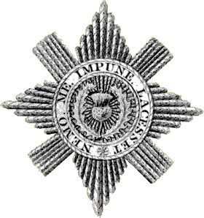
(Draw your own badge here)

(https://www.scotshistoryonline.co.uk/thistle/thistle.html)
Extra’s
Colour in a Unicorn:
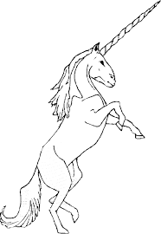

Colour in a thistle:
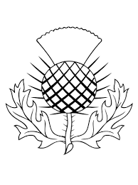

Neolithic colouring:
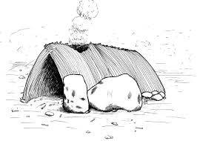Neolithic shelter

(continued…) Neolithic farmer
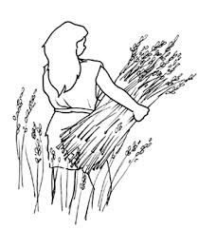
Word search:
WORDS:
- Thistle
- Unicorn
- Beast
- Kilmodan
- St Modan
- Chambered
- Cairn
- Neolithic
Secret Word:
Freedom
Q | E | T | U | U | O | P | W | R | Y | I | A | D
F | G | H | N | J | M | O | D | E | E | R | F | K
T | T | H | I | S | T | L | E | X | V | N | M | N
N | X | V | C | N | M | F | H | E | W | Q | Y | U
E | S | H | R | O | I | U | T | T | R | S | C | X
O | C | E | R | Y | U | K | I | M | O | D | A | N
L | H | D | N | A | L | K | Y | H | G | F | I | P
I | O | I | U | Y | T | R | E | W | Q | M | R | N
T | B | V | C | X | S | T | M | O | D | A | N | X
H | Z | B | E | A | S | T | L | J | G | D | O | U
I | Y | R | W | Q | L | J | F | S | K | H | F | D
C | F | D | S | C | H | A | M | B | E | R | E | D
M | U | H | R | F | C | E | S | D | F | E | S | T

(continued…)
WORDS:
- Birch
- Oak
- Larch
- Rowan
- Spruce
- Beech
Secret Word:
Scotland
Z | L | A | R | C | H | A | J | T | I | W
Q | K | S | F | G | H | B | I | R | C | H
A | S | D | F | H | U | V | Q | P | L | S
B | P | N | K | M | L | R | X | C | V | U
E | R | Y | D | Z | H | K | O | L | E | V
W | U | O | H | W | U | T | A | A | N | M
F | C | T | W | V | J | U | K | Q | R | C
B | E | E | C | H | H | W | R | C | K | L
V | D | N | A | L | T | O | C | S | E | P
J | R | L | O | P | I | R | O | W | A | N

References
- Faith in Cowal | Pilgrim Trails (2020)[online]. Available from < https://www.faithincowal.org/places-for-pilgrims/kilmodan/>
- The Friends of Kilmodan and Colintriave (ND) [online]. Available from < http://www.kilmodan-colintraive.org.uk/history/kilmodan-church/>
- Kent Wildlife Trust (2020) [online]. Available from <https://www.kentwildlifetrust.org.uk/blog/maureen-rainey/10-amazing-facts-about-bluebells>
- Soft Schools (ND) [online]. Available from <https://www.softschools.com/>

